DATA SHEET
Course: Introduction to Public Policy
Institute: Indian Institute of Management, Sirmaur
Project Title: Whose Responsibility? A Policy-Driven Analysis of Human–Animal Conflict
Faculty: Prof. Lakshmi Parvathy

Policy Problem Identified
The IIM Sirmaur campus is experiencing repeated dog bite incidents due to an uncontrolled population of stray dogs within campus premises. Despite the presence of a formal “no pets on campus” rule, weak enforcement, behavioural non-compliance, and unclear institutional responsibility have resulted in physical injuries, psychological distress, and uncertainty regarding medical and financial liability. This reflects a condition of policy paralysis, where policies exist formally but fail to deliver effective public welfare outcomes, transferring uninsured risk to individual students and staff.

Nature of the Problem: A Wicked Policy Issue
The issue constitutes a wicked policy problem due to its complex and multi-dimensional nature. It simultaneously involves public safety, animal welfare ethics, behavioural conflicts, and governance limitations. There is no single authority with clear ownership of the problem, and policy solutions that prioritise one stakeholder group often generate resistance from others. Outcomes remain uncertain and politically sensitive, making the issue unsuitable for linear or purely administrative solutions.

Policy Context and Theoretical Framework
The analysis is grounded in established public policy theories.
Under Social Contract Theory, the campus administration bears responsibility for managing collective spaces and ensuring the safety and welfare of campus residents.
Commons Theory (Elinor Ostrom) conceptualises the campus as a shared resource where individual actions—such as uncontrolled feeding of stray dogs—affect collective safety.
The Prisoner’s Dilemma explains how individually rational and compassionate actions may unintentionally lead to sub-optimal outcomes for the larger community.
Market and Policy Failure is evident in the absence of institutional medical coverage for dog bite victims, which shifts health and financial risk onto individuals rather than pooling it institutionally.

Existing Policy and Implementation Gap
The existing institutional policy prohibits pets on campus. However, this rule has not translated into effective control of the stray dog population. Selective non-compliance, weak enforcement mechanisms, and the absence of clearly defined operational protocols have created a significant implementation gap.
Further, campus-level regulations intersect ambiguously with state-level animal welfare mandates, creating uncertainty over authority, delayed responses, and continued safety incidents.

Stakeholder Mapping
The conflict involves three primary stakeholder groups.
The Campus Administration focuses on institutional liability, enforcement of formal rules, and reputational risk management.
Safety-focused students and staff prioritise physical safety, psychological security, freedom of movement during late hours, and protection from medical expenses.
Animal-sympathy students emphasise ethical treatment of animals, support feeding practices, and often oppose relocation or restrictive measures.
The absence of coordination and incentive alignment among these stakeholders perpetuates policy paralysis.

Evidence and Fieldwork Data: Campus-Level Incidents
Primary field evidence was collected in the form of written complaints and emails submitted by students and staff to campus authorities. These documents provide first-hand accounts of dog bite incidents, fear, and administrative uncertainty.
One student reported being bitten by a white-coloured, one-eyed stray dog within the campus premises, resulting in physical injury and psychological distress. The complaint highlights the unpredictability of stray dogs and explicitly requests urgent administrative action.
Another first-year MBA student documented a late-night incident around 1:30 a.m. in the A1 Block corridor, where a stray dog bit the student while returning to the hostel room. The injury caused missed academic sessions, demonstrating the spillover impact of safety failures on educational outcomes. The complaint further notes that similar incidents have occurred previously.
In a separate communication, a campus community member reported increasingly aggressive behaviour by stray dogs, including access to hostel floors and an attempted bite on a staff member. The report highlights that security personnel were unable to intervene due to unclear authority, revealing governance and enforcement gaps.

INCIDENT 1:-
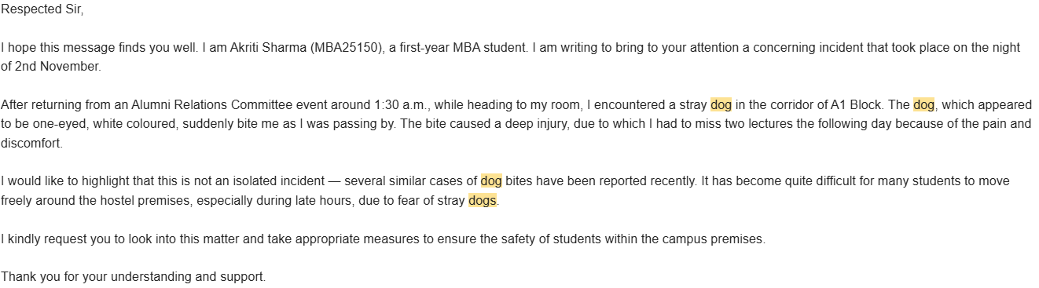
INCIDENT 2:-
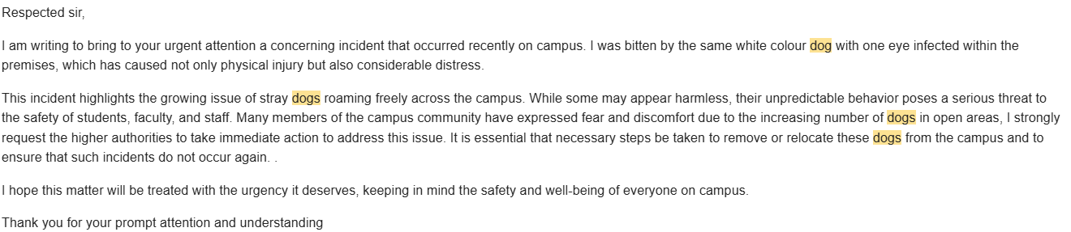
INCIDENT 3:-
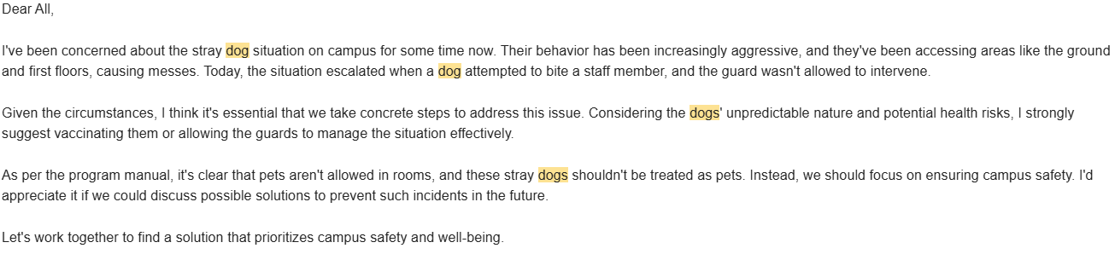
Collectively, these complaints establish recurring incidents, restricted mobility during late hours, and ambiguity in institutional response mechanisms, confirming the presence of a persistent safety risk on campus.

State-Level Evidence: District-wise Dog Bite Data (Himachal Pradesh)
To contextualise campus-level incidents within a broader public health framework, district-wise data on reported dog bite cases in Himachal Pradesh was analysed.
Data shows high incidence across districts, with Kangra (54,649 cases) and Shimla (52,695 cases) reporting the highest numbers, followed by Solan (43,777), Una (31,124), and Sirmaur (26,794 cases). Although suspected rabies deaths are relatively low, fatalities across districts, including Sirmaur, confirm that dog bites represent a serious public health risk.
The inclusion of Sirmaur district data is particularly relevant, as IIM Sirmaur is located within this district. The high number of reported cases demonstrates that campus incidents are not isolated but reflect a broader district-level pattern of unmanaged stray dog populations and incomplete policy implementation.
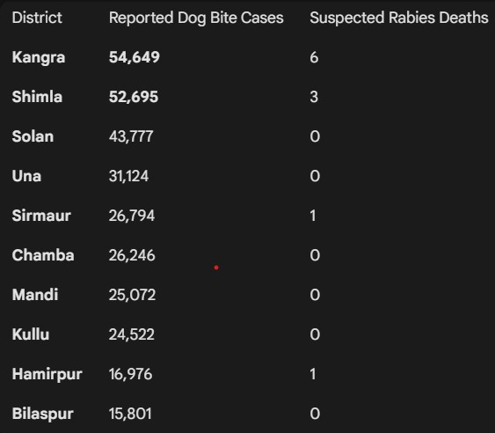
Linking Fieldwork Evidence with Policy Provisions
Campus-level incidents directly expose gaps in policy implementation.
The continued presence of unsterilized and unvaccinated stray dogs indicates weak enforcement of the Animal Birth Control (ABC) Rules, 2023, which mandate sterilization and vaccination of stray dog populations.
Student complaints regarding delayed action and medical uncertainty highlight a disconnect between institutional safety mechanisms and public health objectives under the National Rabies Control Programme, which emphasises timely post-exposure treatment.
The absence of a clearly defined institutional protocol for bite incidents demonstrates failure to operationalise state and national animal welfare and public health policies at the campus level, resulting in uninsured risk being borne by individuals.

Policy Tools and Approach
The proposed approach prioritises behavioural and design-oriented policy tools rather than purely coercive enforcement.
Behavioural nudges and awareness mechanisms are suggested to influence safer human–animal interactions.
Customer journey mapping is used to analyse the “incident-to-recovery” pathway of bite victims and identify breakdowns in medical access and administrative response.
Agile policy design allows iterative policy improvements based on user-centred evidence.
A collective action framework is applied to align stakeholder incentives and protect the campus as a shared common.

Intended Policy Outcomes
The intended outcomes include a reduction in dog bite incidents, clear allocation of institutional responsibility for prevention and treatment, and improved coordination between campus administration and external authorities.
The policy seeks to balance safety mandates with ethical animal treatment while shifting from reactive responses to proactive and preventive risk management.

